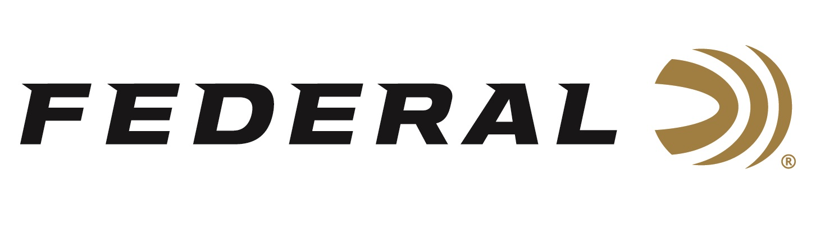

FOR IMMEDIATE RELEASE

Federal Ammunition’s Derrick Mein Captures ISSF Gold in the Dominican Republic

ANOKA, Minnesota – March 5, 2024 – Federal Ammunition congratulates sponsored shooter Derrick Mein on capturing the top spot at the ISSF’s XIV CAT Championship in Santo Domingo, Dominican Republic in Men’s Trap. The competition, that runs through March 9, 2024, serves as an Olympic qualification event drawing more than 100 competitors from 16 nations.

Mein, a former Olympian, qualified for the finals in the Men’s Trap in the second position behind a shooter from Guatemala. In the finals, Mein missed a few early targets before running forty-five straight to win gold over the Dominican’s Eduardo Jose Lorenzo. Since Mein had already qualified the United States for the Olympic games, Lorenzo claimed the quota spot for his home country. Derrick and two teammates combined to capture a bronze medal in the Men’s Team Trap event during the competition.

Federal is the number one choice for shotgun shells and manufactures products in America for all competitive and recreational disciplines. See the full lineup, including the latest High Over All, at www.federalpremium.com.

Federal ammunition can be found at dealers nationwide. For more information on all products from Federal or to shop online, visit www.federalpremium.com. To support America’s shooting team, visit www.usashooting.org to find out more.

Photo credit: USA Shooting

Press Release Contact: JJ Reich
Senior Manager – Press Relations
E-mail: Ammunition@tkghunt.com

About Federal Ammunition
Federal, headquartered in Anoka, MN, is an ammunition brand of The Kinetic Group. From humble beginnings nestled among the lakes and woods of Minnesota, Federal Ammunition has evolved into one of the world's largest producers of sporting ammunition. Beginning in 1922, founding president, Charles L. Horn, paved the way for our success. Today, Federal carries on Horn's vision for quality products and service with the next generation of outdoorsmen and women. We maintain our position as experts in the science of ammunition production. Every day we manufacture products to enhance our customers' shooting experience while partnering with the conservation organizations that protect and support our outdoor heritage. We offer thousands of options in our Federal Premium and Federal® lines-it's what makes us the most complete ammunition company in the business and provides our customers with a choice no matter their pursuit.

